SHILPA SINGH
Social Media Manager • Content Creator • Digital Media Professional
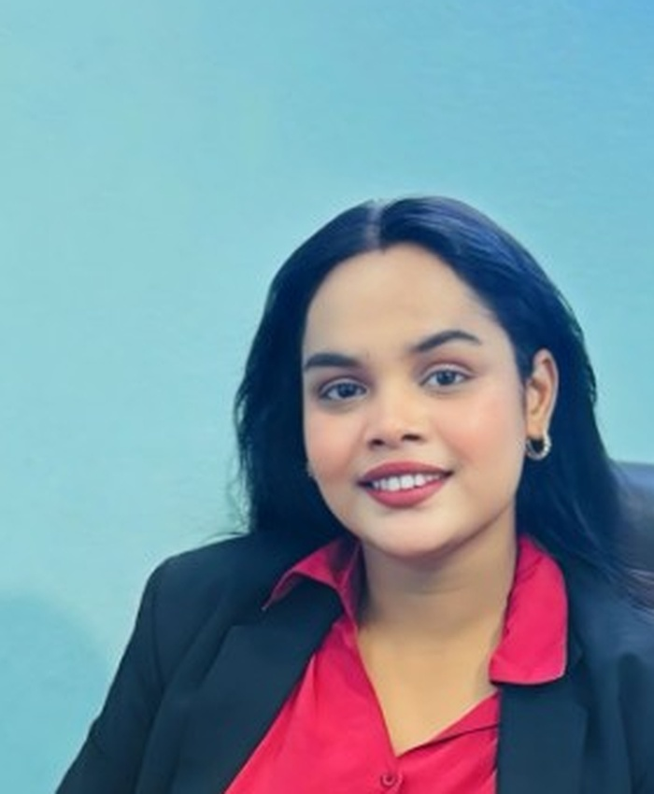 | Contact: 9118222348  Languages: Hindi • English • Bhojpuri
PROFESSIONAL SUMMARY
Creative and results-oriented Social Media Professional with hands-on experience in managing Instagram, Facebook and YouTube platforms, creating engaging content and building online communities. Experienced as a content creator and model with strong skills in Reels/Shorts, long-form videos, captions, hashtags, audience engagement and basic video editing. Comfortable handling social media end-to-end, from content planning and creation to publishing and audience interaction.
CORE SKILLS
Instagram Management • Facebook Management • YouTube Management • Content Creation • Reels & Shorts Creation • Long-Form Video Creation • Caption & Hashtag Writing • Audience Engagement • Social Media Content Planning • Canva Design • Basic Video Editing • Personal Branding & Creator Content
WORK EXPERIENCE / SOCIAL MEDIA EXPERIENCE
Social Media Manager & Content Creator — Independent / Project-Based
• Manage social media platforms and day-to-day content activities.
• Create original content, Reels/Shorts and long-form videos as a creator and model.
• Plan and write captions, hashtags and platform-appropriate content.
• Manage audience engagement and understand strategies for improving reach and interaction.
• Handle content creation, basic editing, publishing and social media presence independently.
SOCIAL MEDIA & CREATOR PORTFOLIO
• YouTube: 1.5 Lakh+ Subscribers
• Instagram: 1.5 Lakh+ Followers
• Additional Instagram Channel: 45K+ Followers
• Strong personal experience in content creation, audience building and social media management.
TOOLS & PLATFORMS
Canva • CapCut • Instagram • Facebook • YouTube
ACHIEVEMENTS
• YouTube Silver Play Button — recognized for reaching 100,000+ subscribers.
EDUCATION
Bachelor's / Graduation — Hotel Management, Babu Banarasi Das (BBD) University
Class 12th — CBSE Board
LANGUAGES
Hindi • English • Bhojpuri

